NTC Thermistor Linearization
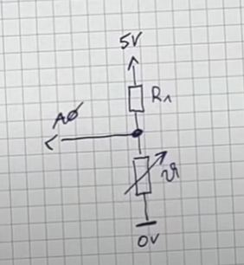
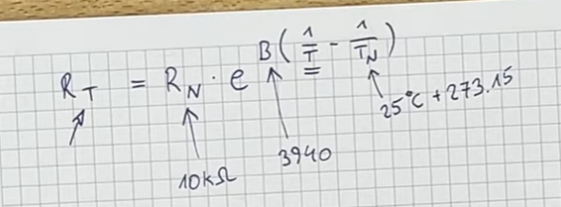

void loop(){

delay(1000);
double v_ntc = 5.0/1023 * analogRead(A0);
double current = (5.0-v_ntc)/10000.0;
double r_ntc = v_ntc/current;

double temp = 1 / ( log(r_ntc/10000.0)/3950 + 1/(25.0+273.15) ) -273.15;

}

